Distinguishing Good Science from Bad D. Duncan NAME _________________________
Comparing a Scientific Publication to TV Coverage about Climate Change
Part I – Analyzing Data
As we’ve discussed in class, “Science is a way of trying not to fool yourself (or be fooled by others). “ You don’t have to be a scientist to think scientifically. But you need to understand the process of science and beware of fake, slanted, or pseudoscience. This includes understanding why different groups of scientists often get different results.
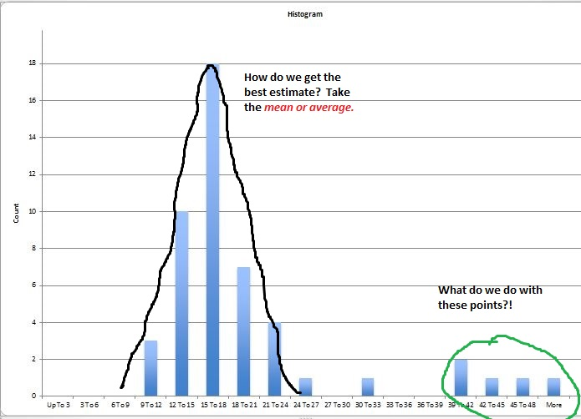
As we also discussed in class, scientists repeat measurements to get an idea of their accuracy and to improve it by averaging individual measurements. Below are student measurements of the height of the C4C building:
- Is the point indicated by the arrow a valid measurement of the height?

- Do you think it is ethical to pick out a measurement other than the mean and say “This is what was found?”

- What would be a good way of expressing the uncertainty of the measurement?

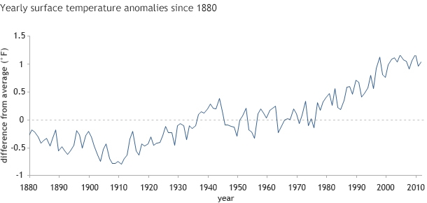
- You may have heard the statement, “Climate Change has stopped.” In this plot are air temperatures, averaged over the Earth, for about the last 15 years.

Is the temperature of the atmosphere rising?

Do you think that climate change has stopped? Why or why not?

- Here is the same data as #4. Do you draw a different conclusion than from the data in #4?

Why do you think the line wiggles up and down from year to year?

Can you think of a way to better see the long-term trends, and not the yearly variation?

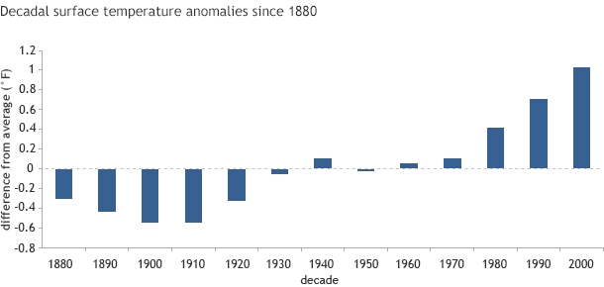
Here is the same data averaged over each decade:

What other sorts of data could you look at to decide if the earth’s climate was still changing or not?

[Your Teaching or Learning Assistant has some examples to show you]

Part II Analyzing TV and Newspaper Reports
- Watch the short TV report from Fox News. They say that “Scientists from the Cato Institute say there is no indication that Global Warming will resume.” It is good that they give a reference to their source of data. Look up the Cato Institute on line. What kind of science do they specialize in?

Compare that to the American Association for the Advancement of Science (http://www.aaas.org/about-aaas ) or http://en.wikipedia.org/wiki/American_Association_for_the_Advancement_of_Science
About how many members does the AAAS have?

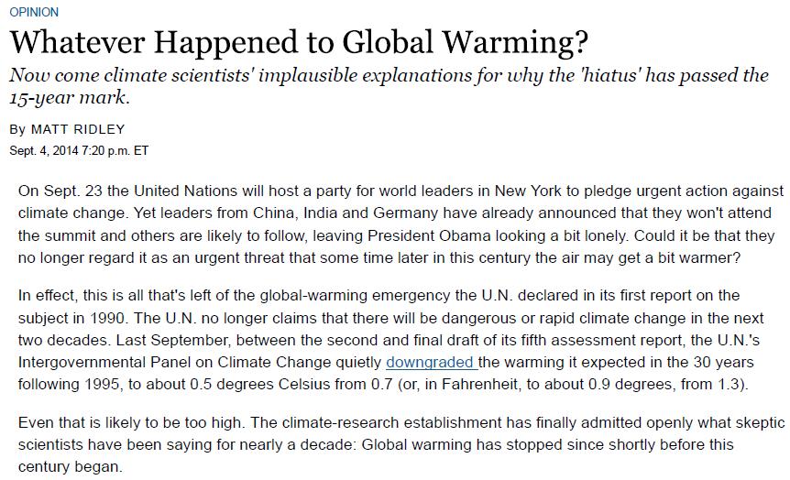
- The video on Fox is similar to the Wall St. Journal article that appeared a few days earlier:

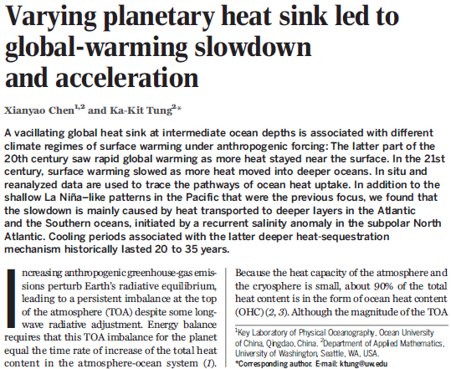
Here is the original scientific article. See if you are more accurate than the Wall St. Journal writer:

Note that “vacillating” means changing, a heat “sink” is something that stores energy, and anthropogenic means, “human-caused.”
Do the scientists report that warming of the earth has stopped?

Where do the scientists say the energy caused by humans is (mostly) going?

What changed from the later part of the 20th century to the start of the 21st? (Where did more of the human-caused heat go?)

About how long is this trend likely to continue?

What fraction of heat energy is stored in the ocean vs. the atmosphere and cryosphere (ice)?

When we talk about climate change should we be talking about air or sea temperatures?

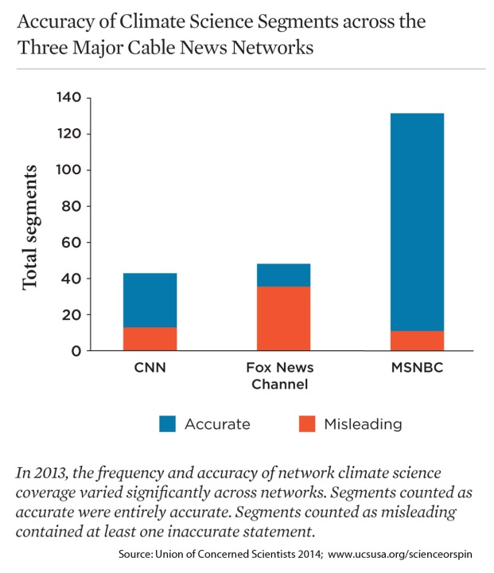
Here are ocean temperatures for the last 50 years. 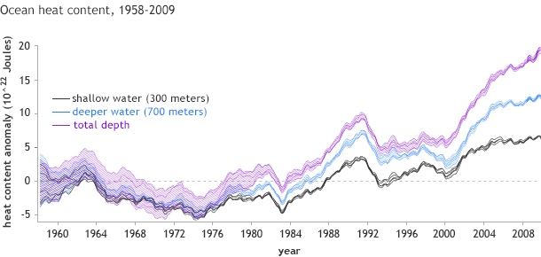

Here is a survey of TV climate reports, made by scientists who checked them for accuracy. What grade would you give the 3 networks if you were grading them? (A, B, B+, C, etc.)

You might find this response interesting. It is by a Professor at Columbia who is not a scientist himself, but who obviously reads carefully. A great example of what a careful nonscientist can learn…
Ridley's "smoking gun" is a paper last week in Science Magazine by two scientists Xianyao Chen and Ka-Kit Tung, which Ridley somehow believes refutes all previous climate science. Ridley quotes a sentence fragment from the press release suggesting that roughly half of the global warming in the last three decades of the past century (1970-2000) was due to global warming and half to a natural Atlantic Ocean cycle. He then states that "the man-made warming of the past 20 years has been so feeble that a shifting current in one ocean was enough to wipe it out altogether," and "That to put the icing on the case of good news, Xianyao Chen and Ka-Kit Tung think the Atlantic Ocean may continue to prevent any warming for the next two decades."
The Wall Street Journal editors don't give a hoot about the nonsense they publish if it serves their cause of fighting measures to limit human-induced climate change. If they had simply gone online to read the actual paper, they would have found that the paper's conclusions are the very opposite of Ridley's.
First, the paper makes perfectly clear that the Earth is warming in line with standard climate science, and that the Earth's warming is unabated in recent years. In the scientific lingo of the paper (it's very first line, so Ridley didn't have far to read!), "Increasing anthropogenic greenhouse-gas-emissions perturb Earth's radiative equilibrium, leading to a persistent imbalance at the top of the atmosphere (TOA) despite some long-wave radiative adjustment." (Infrared) In short, we humans are filling the atmosphere with carbon dioxide from fossil-fuel use, and we are warming the planet.
Second, the total warming is distributed between the land and ocean surface on the one hand and the ocean deep water on the other. The total rise of ocean heat content has continued unabated, while the proportion of heat absorbed at the surface and in the deeper ocean varies over time. Again, in the scientific lingo of the paper, "[T]his forced total OHC [ocean heat content] should be increasing monotonically over longer periods even through the current period of slowed warming. In fact, that expectation is verified by observation ...". In other words, the ocean has continued to warm in line with predictions of just such a phenomenon seen in climate models.
Third, it is the "vertical distribution" of the warming, between the surface and deep water, which affects the warming observed on land and at the sea surface. The point of the paper is that the allocation of the warming vertically varies over time, sometimes warming the surface rapidly, other times warming the deeper ocean to a great extent and the surface water less rapidly. According to the paper, the period of the late 20th century was a period in which the surface was warmed relative to the deeper ocean. The period since 2000 is the opposite, with more warming of the deeper ocean. How do the scientists know? They measure the ocean temperature at varying depths with a sophisticated system of "Argo profiling floats," which periodically dive into the ocean depths to take temperature readings and resurface to transmit them to the data centers.
So, what is Ridley's "smoking gun" when you strip away his absurd version of the paper? It goes like this. The Earth is continuing to warm just as greenhouse gas theory holds. The warming heats the land and the ocean. The ocean distributes some of the warming to the surface waters and some to the deeper waters, depending on the complex circulation of ocean waters. The shares of warming of the surface and deeper ocean vary over time, in fluctuations that can last a few years or a few decades.
If the surface warming is somewhat less in recent years than in the last part of the 20th century, is that reason for complacency? Hardly. The warming is continuing, and the consequences of our current trajectory will be devastating unless greenhouse gas emissions (mainly carbon dioxide) are stopped during this century. As Chen and Tung conclude in their Science paper, "When the internal variability [of the ocean] that is responsible for the current hiatus [in warming] switches sign, as it inevitably will, another episode of accelerated global warming should ensue."

