**Measuring the Height of a Building**

Measure to the roof here

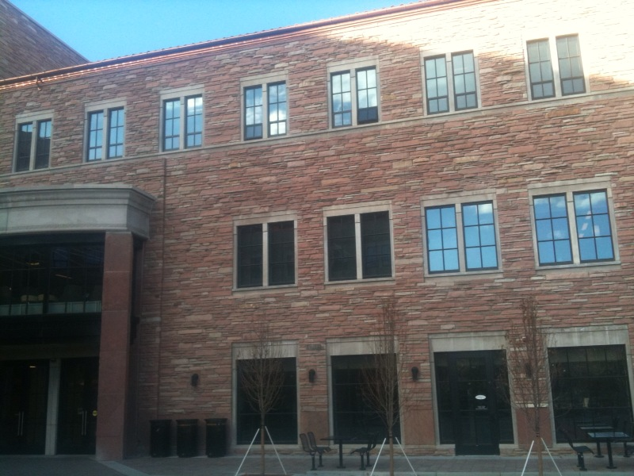

**Name 1: _____________**

**Name 2: _____________**

**Name 3: _____________**

**Your Instructor will ask you to work in a group on this exercise. Write down all names, but you only need to turn in one paper.** (Note there are 4 pages to look at)

**What’s the Big Idea of this activity?**

Science involves using creativity and imagination to figure things out. In Astronomy we often have to measure things we can’t touch because they are so far away. Also, whenever you measure something it is important to understand the how accurate the measurement is.

**Learning Goals**

* Measure something (The roof height of the Center for Community or C4C building) you cannot touch. ***\*\*\*****Use creativity in devising your own method to do this****\*\*\****
* Learn how to estimate the accuracy of your measurement.

**IMPORTANT NOTE:**  Many labs are like cookbooks –they tell you what to do. That is not the way real science works. *Real science* (as opposed to boring classroom science) is all about using your imagination. That’s why we don’t tell you a specific method. You will invent one…

**Activity:**

**Learning Goal I**: Measure the size of something (the roof height of the C4C building) that you cannot touch.

**Experimentation**

Part 1: Your apparatus includes a **meter stick** and a large cardboard triangle whose **sides are in a ratio of 2 to 1.**

* + Use creativity in devising your method. Discuss your ideas with the others in your group of 3. Start with the following hint, that reminds you of the properties of ratios:
  + **HINT:**  The following two triangles are *similar* and the sides are in the ratio of 2 to 1*.* Triangles are similar if the *corresponding angles are equal,* and that’s true here. So the ratios of any two sides in the first triangle are equal to the ratios of the corresponding sides in the second triangle. If A=1’ how large is B? Answer: B=2’ If D = 50 feet, how large is E?  **Write your answer here and show it to**

**your Instructor:** _________



**x**

**x**

Mathematically, A/B = D/E. If you know 3 parts of a ratio you can find the 4th.

You could also use trigonometry if you measured the angle x. The ratios A/C and B/C are called the *sine* and *cosine* of the angle x, and A/B is the *tangent*. So you could measure one side, and an angle (if you had a protractor) and figure out the other side. But you don’t need to, because we’ve already told you the sides are in a ratio of 2 to 1.

Notes and Observations:

Sketch your method of measuring the building here. Include the building in your drawing. Draw in 2 dimensions, not 3.

**Show the drawing to your instructor and explain your plan BEFORE you do your measurements!**

Question(s):

I.1) What is the height of The C4C building? __________________________

**(units)**

**Learning Goal II**: Learn how to estimate the accuracy of a measurement.

Question(s):

II.1) What do you think is the accuracy of your measurement? Think about this carefully, please.

___________________  **(units)**

II.2) How did you estimate your uncertainty?

**Hint:**

Part of a **scientific attitude** means understanding data and the errors that come with it. Whensomeone makes a claim, you *always* should ask, "What data or evidence supports that claim?” *and* "How good is that data?"

II.3) If you compared your measurement of the height of The C4C building to the measurement of another group, how different would you expect them to be?

II.4) How does that compare to your estimate of uncertainty?

**Discussion Question:**

How do astronomers use geometry and trigonometry to measure distances? What do they measure distances to this way?