ASTR 1020 Recitation Activity: The Sun, seen from Space and from the Earth

Name(s) ___________________________ ___________________________

Goals:
- (Clear skies permitting) Sketch a sunspot using the Sommers Bausch solar telescope.
- Use time-lapse video of the sun taken in visible light to follow the movement of sunspots and determine the rotation period of the Sun.
- Examine time-lapse videos of the sun taken from space in visible, ultraviolet, and X-ray light and sent back to earth.
- Appreciate that observations from space allow us to learn far more about the sun than observations from the ground made only in visible light.

Definition: Time-lapse means speeding up time so that hours or days go by in a few minutes.

Some Background Information about the Sun and Sunspots:
- Different layers of the sun’s atmosphere have different temperatures. Surprisingly, the further out in the atmosphere you go the hotter it is. The outmost layer (corona) is hotter than the middle layer, the chromosphere, and the chromosphere is hotter than the lower photosphere, the layer you see with just your eyes and a dark filter.
- Sunspots are seen in the photosphere. They are areas of strong magnetic activity.
- Sunspots appear dark because they are not as hot or bright as the area surrounding them.
- They can grow or die out as they move across the surface of the Sun.

What layer of the sun have YOU seen? ________________________________

Equipment: The Sommers Bausch Observatory solar telescope, images from a website connected to the Solar Dynamics Observatory, a NASA satellite that observes the sun in many wavelengths.
Meter stick or other ruler.

WARNING: The intense solar light from the heliostat can cause eye damage! Do NOT look up the beam of sunlight!
Mapping Sunspots

Mapping and counting sunspots was the original way astronomers studied solar activity. It is how the 11 year sunspot cycle was discovered, and now we know that all forms of solar activity including the solar flares that affect the earth are more intense every 11 years at “solar maximum.”

Your TA, LA, or Instructor will use the solar telescope (heliostat) to focus an image of the Sun. If you can find a sunspot, sketch it on this recitation paper. Do not write on the wall or the solar telescope screen! Sketch

Measure the size of the entire solar image and write the value here: _____________________

The earth is approximately 1/100 the size of the sun. How large would the earth appear if it was as far away as the sun and seen with the solar telescope? ___________________________

Measure the size of your sunspot: ______________________ How does the size of your sunspot compare to the size of the earth?

If it is cloudy, you can do the above using a satellite image! See below.

Using Satellite Images

The Solar Dynamics Observatory (SDO) is a NASA mission designed to help understand the causes of solar variability and its impacts on Earth by studying the solar atmosphere in many wavelengths simultaneously. Initials such as “AIA” or “HMI” refer to instruments carried on the satellite. Numbers (171, 304, etc.) tell the wavelengths of light each instrument detects. The units are angstroms; or 10⁻⁷ mm. Visible light ranges from about 4000-7000 angstroms. Numbers such as 304 or 1600 are ultraviolet light. What kind of energy do you think a number of 94 is? ______________
You can see a description of the images taken by SDO here:
http://www.nasa.gov/content/goddard/nasas-sdo-shows-the-suns-rainbow-of-wavelengths

First you will use visible light images to measure the rotation of the sun using sunspots. The visible light images are similar to the drawing you made (if it was clear), but there’s data for many months.

Using a web browser go to http://sdo.gsfc.nasa.gov/data/aiahmi/
In the box that says “Telescope” select HMI Intensitygram (Orange). These are images taken with visible light.

Select a date range to give you about 30-40 days’ worth of data. You have to click 3 times to select a date and time, so be patient. Scroll down to select 10 in the n-th box so that only every 10th image will be loaded. (This is important as there is a download limit, and otherwise it will take forever.)

When you click on Submit, at the bottom of the page, a time-lapse video showing the Sun’s image for the past month will be played. As you watch sunspots move across the surface of the Sun, you can determine the time that it takes them to move by stopping the movie and recording the date and time from the image. Unfortunately the Orange movies you just saw don’t display the date and time. But the AIA1700 movies do, and they also show the photosphere. So use them. The format of the date and time information shown under the pictures is: yyyymmdd_hhmmss. Now you are going to determine the rotation period of the sun.

- List the beginning and end times for the motion of 3 sunspots as they move completely across the Sun. You will need to change hours into fractions of days for the Difference column.
Sunspot | Beginning Date & Time | Ending Date & Time | Difference (days)
1
2
3
Do your 3 values differ from each other? If they do, why do you think that is?

- What is your value for the rotation period of the Sun (in days) based on the sunspot motion you measured? _________________

Now you will use videos taken in ultraviolet and X-ray light.

The 3 main layers of the sun’s atmosphere are the photosphere (the lowest visible layer), which you see with your eyes and the solar telescope, the chromosphere, and the corona (the outermost or highest layer). The photosphere is the coolest layer and the corona the hottest.

- Choosing between visible, ultraviolet, and X-ray light, which is best to view the photosphere?
______________________. Which is best to view the chromosphere? ____________________
Which is best to view the corona? __________________________________

Go back to the SDO web page and change the “Telescope” box to AIA 304. Choose “Submit” and watch the time-lapse ultraviolet video of the sun.

Magnetic fields are important in the sun but you can’t see magnetic fields…or can you? Did you ever “see” the magnetic field of a bar magnet?

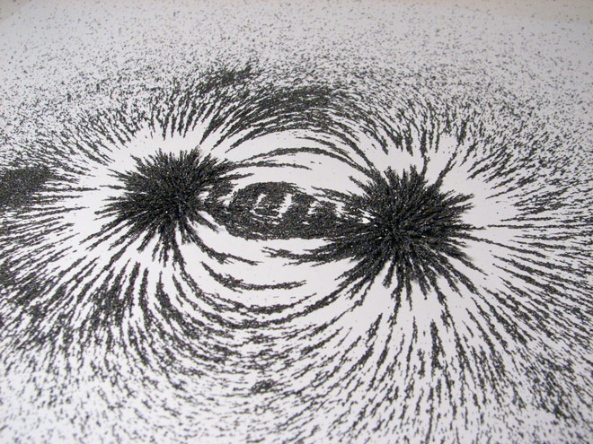
The figure at left shows small pieces of iron sprinkled on a piece of paper.

- Do you think there is a bar magnet below the paper? How can you tell? _______________

_______________________________________

Change the “Telescope” box to AIA 171 and hit “Submit.” This will download a video taken in X-ray light.

- Watch the video carefully. Do you see evidence of magnetic fields on the sun? If so, what is your evidence?

If you download video “HMI Magnetogram,” you will see where astronomers measure magnetic fields, with black and white representing the different magnetic polarity (N and S).

Which polarity leads (is ahead in the direction of rotation)? _______________________
Is your answer the same for both hemispheres of the sun? __________________

If you download video “Composite AIA 171, HMI Magnetogram,” you can see a beautiful video that overlays the X-ray video and the magnetic field video. Can you see the patterns of magnetic field? Do the areas of strong magnetic field and loops of hot gas coincide? _______________

Some of the very hot gas of the sun’s corona that you see in video AIA 171 escapes into space and forms the “solar wind.” Some of these electrons and protons hit the earth. Because of Earth’s magnetic field the path of the particles is bent and they come down near the north and south poles, making the aurora: the northern and southern lights.

BONUS –

If you do this bonus you will get an extra 40% credit for this lab.
You learned in class that the sun rotates at a different speed at the equator and at the poles. Can you tell that from your sunspot rotation measurement? Measure the rotation of sunspots at different latitudes on the sun. To determine latitude, use these grids http://solar-center.stanford.edu/solar-images/latlong.html that provide an overlay of latitude and longitude data for the Sun for different months. The grids show times when the Sun is tilted more or less toward the Earth. Get a transparency for the appropriate grid for your dates. You don’t have to be more accurate than 5 degrees or so.

You may want to add one more spot farther from the equator if you can find one.

Sunspot | Beginning Date & Time | Ending Date & Time | Difference (days) | Latitude of spot
1
2
3
4

